

|  |
| --- |
| EPAM DevOps External Training  PowerShell essentials |
| Scripting: PowerShell basics. Part 1  Home tasks |

## Completed by: ___ Your name ___

|  |  |
| --- | --- |
| Task 1 | Past script text and screenshots |
| 1. Show help output on the “help” cmdlet. |  |
| 1. Do the same but show a detailed reference. |  |
| 1. Do the same but show only examples. |  |
| Task 2 |  |
| 1. Get in the console all cmdlets, which perform "Set" action. |  |
| 1. Get a list of all cmdlets, that manipulate with files. |  |
| 1. Get a list of all cmdlets for working with objects. |  |
| 1. Get a list of all aliases. |  |
| 1. Create your own alias for any cmdlet you like. |  |
| Task 3 |  |
| 1. Create a variable of string type |  |
| 1. Get the list of methods and properties of this variable |  |
| 1. Check the length of the string |  |
| 1. Remove all spaces from the string at the end |  |
| 1. Make all letters in the string uppercase |  |
| 1. Create a string containing an integer (e.g. "355"). From this string, get a variable of integer type. Make sure that the variable is of System.Int32 type. |  |
| Task 4 |  |
| 1. Create an array of 10 elements. |  |
| 1. Get the fifth element from the beginning. |  |
| 1. Get the third element from the end. |  |
| 1. Add the eleventh element at the end of the array. |  |
| 1. Get a new array containing 3-7 elements of the first array. |  |
| 1. Get a new array containing 9-4 elements of the first array. |  |
| Task 5 |  |
| 1. Create a hash table describing your table (height, length, width, color, material, etc.). |  |
| 1. Get the value of 2-3 elements in different ways. |  |
| 1. Change the value of any element. |  |
| 1. Add another one element to an existing hash table with a null value. |  |
| Task 6 |  |
| 1. Get list of the PowerShell session variables. |  |
| 1. Describe each variable. |  |
| Task 7 |  |
| 1. View a list of methods and properties of a cmdlet “Get-process”. Looks carefully through the whole and look what are available for you. |  |
| 1. Get list of all processes on a local computer. |  |
| 1. Get the list of processes including information about the process owner. |  |
| 1. Try to get in the console *CPU usage*, *Start time* and *system path* for the “explorer” process. Tip: choose any process from the list of “Get-process” and manipulate with it. |  |
| Task 8 |  |
| 1. Get a list of system updates on your PC. |  |
| 1. Find out which language is installed for Windows UI. |  |
| 1. Fine cmdlet which shows current time and date. |  |
| 1. Generate a random number (in any way) |  |
| 1. Open any text file in notepad (no matter how) and close it with the help of PowerShell. |  |

## Hometasks requirements

1. Use clear formatting.
2. No errors on execution.
3. Use best practices during development.
4. Your scripts should be readable.
5. Use comments where is needed.
6. Use console output and logging to show result of your work

## hometask results

1. Create screenshots containing the following information:
   1. All screenshots should contain system datetime of your host OS.
   2. Output of the console with execution result of your code. If the result is a long list, it is enough to display the beginning of the list. Example:

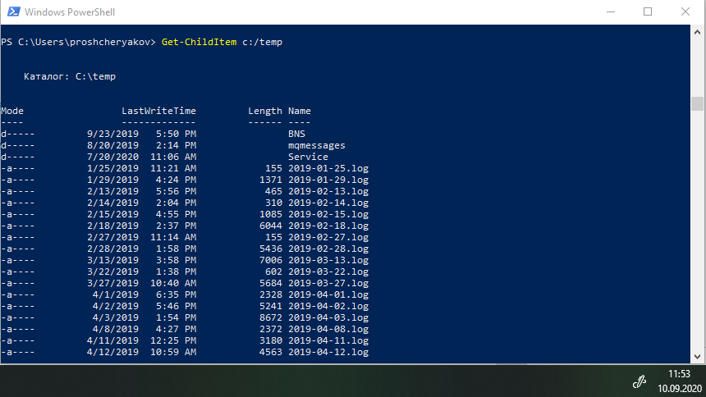

1. Rename the file with the completed task in the format: **DevOps.PS.1_IVANOV.docx**
2. Send the file to the trainer in the attachment (without! archiving), the letter specifies only the topic in the format, as well as the file name: **DevOps.PS.1_IVANOV**.

|  |  |
| --- | --- |
| proshcheryakov@gmail.com | Aliaksei_Babuk@epam.com |
| |  |  |  |  |  |  |  |  |  |  |  |  |  |  |  |  |  |  |  |  |  |  | | --- | --- | --- | --- | --- | --- | --- | --- | --- | --- | --- | --- | --- | --- | --- | --- | --- | --- | --- | --- | --- | --- | | |  | | --- | | Олег Мудрак | | Александр Свириденко | | Алексей Дубовик | | Александр Серебков | | Александра Занько | | Алексей Морозько | | Анастасия Пётух | | Анастасия Таранова | | Андрей Бобрик | | Андрей Матскевич | | Андрей Рубан | | Андрей Трибуховский | | Андрей Вареник | | Андрей Астровский | | Артем Рачок | | Дмитрий Предко | | Дмитрий Сазон | | Евгений Рыхтер | | Евгений Войтеховский | | Геннадий Ивашкевич | | Игорь Бобровник | | | |  |  |  |  |  |  |  |  |  |  |  |  |  |  |  |  |  |  |  |  |  |  | | --- | --- | --- | --- | --- | --- | --- | --- | --- | --- | --- | --- | --- | --- | --- | --- | --- | --- | --- | --- | --- | --- | | |  | | --- | | Игорь Шульган | | Ирина Крылова | | Константин Коптяков | | Мария Костенко | | Михаил Бакиновский | | Никита Шараев | | Павел Матюшевский | | Роман Родионов | | Руслан Быков | | Сергей Лесюков | | Сергей Харлап | | Владимир Степанович | | Владислав Петровец | | Вадим Слепив | | Валерий Барай | | Василий Симонов | | Виктор Шудейко | | Виктор Ворона | | Ярослав Вердыш | | Евгений Михальчук | | Юрий Лапцевич | | |

## helpful materials

Do not fear the Shell:

<https://mva.microsoft.com/en-US/training-courses/getting-started-with-powershell-30-jump-start-8276>

Approved Verbs for PowerShell:

<https://docs.microsoft.com/en-us/powershell/developer/cmdlet/approved-verbs-for-windows-powershell-commands>

Data types:

<http://www.tutorialsteacher.com/csharp/csharp-data-types>

PowerShell best practices:

[<https://github.com/PoshCode/PowerShellPracticeAndStyle>](https://github.com/PoshCode/PowerShellPracticeAndStyle)

[<http://powershell-guru.com/best-practices/>](http://powershell-guru.com/best-practices/)